OPN LUNCHES  Monthly…..  For the ‘Young at Heart’?!.....  Call Care 46700700 for bookings or to join the seniors’ groups at Care Goondiwindi.  Care Seniors Group= trips, lunches, shows, dinners, entertainment, raffles, music, dancing, morning teas, health information & friendships made…. | Care Seniors Newsletter SEPTEMBER 2023  Older Persons Network  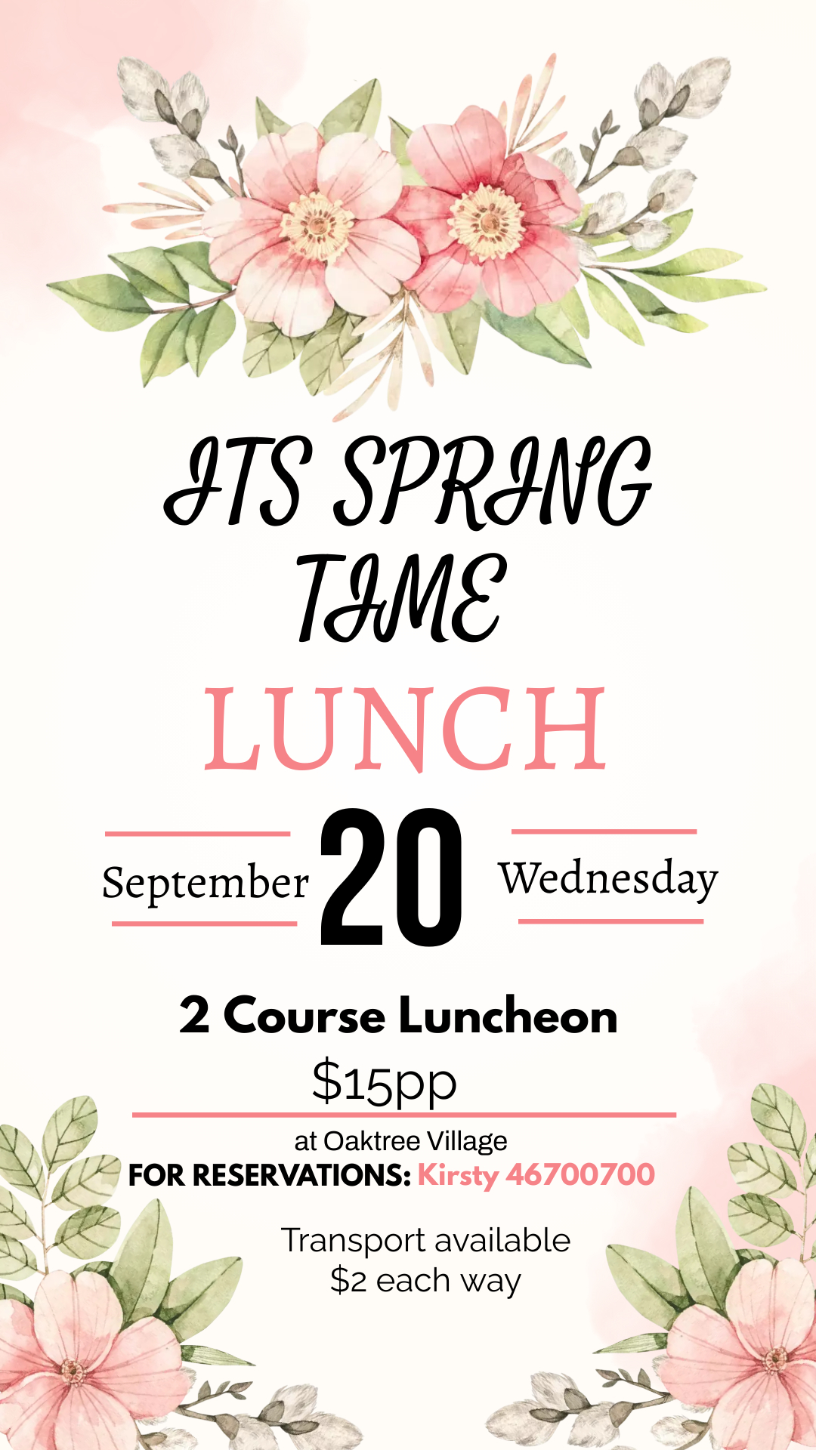  LOOKING FOR A HANDYMAN OR LAWN MOWER??  Handymen -  BJG Woodwork & Handyman Services – Ben 0408906865  Handyman Services – Alain 0456616476  Lawnmowers –  Alex Haines - 0435545102  Alicia Black Ph: 0428505584  Gold Standard Lawns – Jesse 0492895938  Cutty’s Lawn’s 0439357405  YDS Yard Maintenance – 0402537530  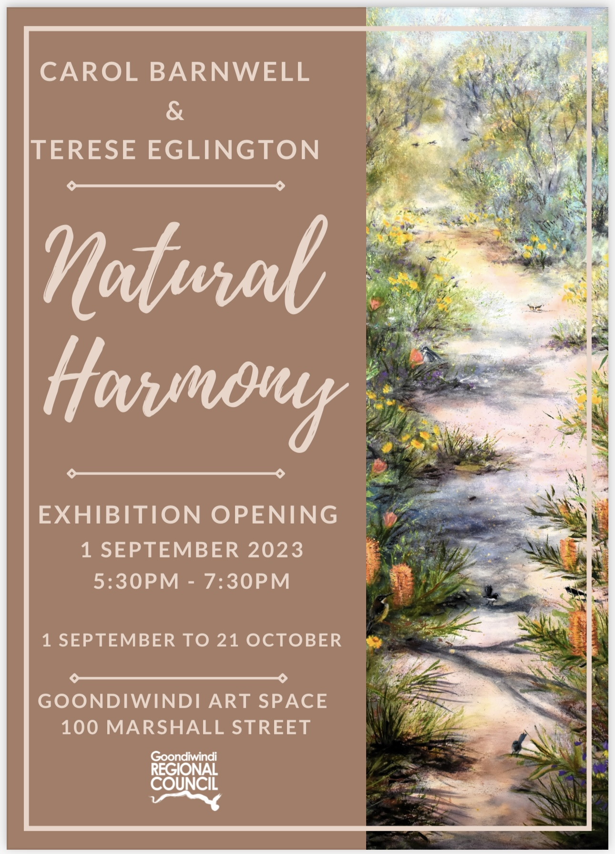  ATTENTION – ALL CARE SENIORS PROGRAM MEMEBERS!  PLEASE LET US KNOW IF YOU WOULD LIKE TO BE REMOVED FROM OUR MAILING LIST…. IT IS COSTLY TO SEND A NEWSLETTER EACH MONTH IF YOU DO NOT INTEND ON COMING TO ANY EVENTS/TRIPS/LUNCHES. Alternatively, if you have email, we can send you a copy via email.  CARE GOONDIWNDI – Will now be closed from 12:30pm – 1:30pm Monday to Friday. New opening hours are from 8:30am until 12:30pm & 1:30pm – 4:30pm.  MEDICO SERVICE: This service is available to take clients to essential medical appointments between 9:00am – 2:45pm. It is also available to take clients to Care run events. Medico service fee is $2 per trip. Please call the Care office to book the medico service 46700700.  OTHER SERVICES -  EMERGENCY RELIEF: Operating on Tues, Wed & Thurs. Please ensure you have access to your Centrelink Income Statement. Times: 9:30-11:30am & 2pm-3pm.  JP/COMMISSIONER OF DECLARATIONS: This service can still be accessed but you MUST call the office first for an appointment 46700700.  LEGAL AID: Is no longer offered at Care Goondiwindi  NON-INTEREST LOANS SCHEME (NILS): Nils loans are interest free loans for essential household items & car repairs/registration. Please call the office 46700700 to make an appointment.  Birthdays –  SEPTEMBER:  1st Margaret Manton  9th Peter Venables  9th Robyn Pegler  13th Verna Wilmot  15th Pat Lee  17th Marie Lloyd  18th Daphne Klowss  20th Gloria Wright  30th Avril Burton  17th Helen Elkema  13th Pam Sullivan  29th Lyn Moynihan  30th Denise Masters  Gourmet in Gundy – 8th – 10th September  McIntyre Areo Fly-in breakfast – 10th September  Texas Country Music Festival – 21st – 23rd September  Goondiwindi Cup – 9th September  50th Anniversary Shoot – 1st – 3rd September  Green-up Showcase – 24th & 25th September  Gdi Cotton Cutting – 8th-10th September  Goondiwindi Markets – 24th September  Xmas Markets – 2nd Dec  SAVE THE DATE:
Contact Us

CARE Goondiwindi
111 Callandoon Street
Goondiwindi 4390 Q
www.cargoondiwindi.org.au
Kirsty.dowling@caregoondiwindi.org.au

